66118111978882



BACHELOR OF COMPUTER SCIENCE:
INTERNSHIP REPORT
INTERPRETER:
TRAORE CHEICK OUMAR
FACULTY ADVISOR:
DR. ANDRE CLAUDE BAYOMOCK

INTERNSHIP SUPERVISOR:
MR. N'DRI AIME BRICE STÉPHANE
THEME :
PROJECTION OF BUDGETARY REVENUES USING ARTIFICIAL INTELLIGENCE

UNION-DISCIPLINE-WORK
REPUBLIC OF CÔTE D'IVOIRE

THANKS

Before going any further, we would like to express our gratitude to all those who contributed to the success of this experiment:
Mr. KEITA Mahamadou, Director of DSIB, thank you for receiving us at his facility.
The entire teaching staff and administrative personnel
The entire DSIB team for their welcome, support, and kindness.
Mr. N'Dri Stephane for his guidance and valuable advice

DEDICATION

To my parents, for all their efforts and sacrifices.

FOREWORD

The public finance sector in Côte d'Ivoire is undergoing a gradual digital transformation. The Directorate General of Budget and Finance (DGBF), as a key player in national public finance management, relies on increasingly sophisticated IT systems to meet the challenges of modern budget planning.
The Directorate of Budget Information Systems (DSIB), a key component of the DGBF, is responsible for designing, developing, and maintaining the digital infrastructure that supports these critical processes. It is within this context that the project to develop a revenue projection system based on artificial intelligence was initiated.
This report presents the work carried out during a three-month internship, during which a complete computer system was designed and implemented to automate the projection of state budget revenues. This project is part of the broader digital modernization initiative of the Ivorian public administration.

SOMMAIRE

INTRODUCTION 4
PART I: PRELIMINARY STUDY 5
1. COMPANY PRESENTATION AND ORGANIZATION 6
Organization 9
2. Study of the existing situation 10
a. Project context 10
b. Project objectives 10
c. Project scope 11
d. Information gathering technique 11
e. Presentation of the existing situation (outcome report) 12
f. Analytical technique or method 16
g. Management rules 16
h. Data dictionary 17
i. Theoretical access structure 20
PART II :STUDY CONDUCTED 23
I. Future data modeling. 24
Future management rules 24
Future Data Dictionary: 25
Future theoretical access structure: 26
Future Conceptual model of data: 27
Relational Logical Data Model (RLM) 28
Physical Data Model (PDM) 30
II. Functional and dynamic models 32
II-1 Use Case Diagram 32
II-2 Activity Diagram 39
II-3 Sequence diagram 40

INTRODUCTION
The Directorate General of Budget and Finance (DGBF) faces a major challenge each year: accurately forecasting budget revenues to guide public investment and national policies. However, the process of determining these projections is not yet fully automated, which can lead to risks that may affect the reliability of the data produced.
In a context marked by the emergence of new technologies, increasingly powerful data analysis and processing tools are now available, particularly thanks to Artificial Intelligence. Integrating these technologies into the DGBF's application ecosystem thus represents a major opportunity to improve the performance and productivity of its services.
It is with this in mind that we were asked to conduct a study on the theme: "The implementation of a system for projecting budgetary revenues using Artificial Intelligence".
This report is structured in three main parts. The first part is devoted to the preliminary study, which analyzes the existing situation and identifies the shortcomings of the current system. The second part focuses on a detailed study of the proposed solutions. Finally, the third part presents the project's implementation through the concrete deployment of the developed system.

PART I:

PRELIMINARY STUDY

COMPANY PRESENTATION AND ORGANIZATION

The DGBF (Directorate General of Budget and Finance) is a key player in public finance management in Côte d'Ivoire. Although the internship took place at the DGBF, this presentation focuses specifically on the DSIB (Directorate of Budgetary Information Systems), the department within which the internship was carried out.

Missions of the DSIB
The DSIB's main missions are:
- Monitoring of the IT master plan:
Ensure the updating and management of the DGBF's IT master plan in order to align IT projects with the ministry's strategic objectives.
- Security and availability of IT tools:
To guarantee the security, continuity and availability of systems and applications, in order to ensure the smooth running of budgetary operations.
- IT project management:
Manage DGBF's IT projects, from their conception to their implementation, ensuring their consistency and quality.
- Studies and application development:
Conduct preliminary studies, develop and maintain the applications and software packages necessary for budget management.
- User support:
To provide technical support and assist the various departments of the DGBF in the optimal use of IT tools and equipment.
- Acquisition and maintenance of equipment:
To ensure the acquisition, maintenance and updating of IT equipment and resources made available to the ministry's departments and services.
- Network and telecommunications maintenance:
Ensuring the stability and security of computer and telecommunications networks to guarantee the smooth flow of information.
- Implementation of the IT quality plan:
Deploy and monitor the IT quality assurance plan to enhance system reliability and improve overall performance.
- User training:
Participate in user training to promote the adoption and effective use of various computer applications.

Main Activities
The activities of the DSIB are structured around three major axes:
Managing IT projects
The execution of studies and application developments to meet the business needs of the DGBF.
The deployment of new infrastructure and the implementation of security measures for information systems.

Operations and technical support
Assistance to DGBF services for the daily use of IT tools.
Corrective and preventive maintenance of equipment, IT support and networks, ensuring smooth operation of the information system.

L'Optimization and modernization of tools
- Monitoring of the Integrated State Budgetary Operations Management System (SIGOBE), a central tool enabling budget preparation, input of projection data, budgetary accounting and closing of the financial year.
- Strengthening the security and safeguarding of the budget information system.
- Implementation of modernization initiatives, such as the transition from analog to IP telephony, to improve internal communication.

Organization

Directorate of Budgetary Information Systems
(DSIB)

Sub-Directorate of Operation and support
Sub-Directorate of Infrastructures and Equipement
Sub-Directorate of Security and Data Integity
Sub-Directorate of studies and Application development

Operation and Budget Application Services
Infrastructure Techniques Services
Data Integrity Services
Studies and Making Services

Network Infrastructures and Telecommunication Services
Operation and Application support Services
Security and Computer Operations Services
Development and Application Integrity Services

Maintenance and Technical Support Services
Equipment Services

Digital Communication Services
Application Quality and Consistancy Services

- Study of the existing situation

a. Project context
Projecting budget revenues is a major challenge in public finance management, as it determines the State's ability to anticipate its resources and effectively guide its economic policies and public investments. Within the Directorate General of Budget and Finance (DGBF), this activity is carried out within a structured institutional framework and primarily involves the Directorate of Budgetary Policies and Synthesis (DPSB), working closely with the various financial agencies.
As part of this study, an interview was conducted with an official from the DPSB (Directorate of Public Finances and Budget). This exchange provided a better understanding of the current operation of budget revenue projections and their relationship to the macroeconomic framework. It emerged that, while the macroeconomic framework provides a general structure, the core of the work relies on the analysis of revenues derived from the past performance of the financial agencies, enriched by certain macroeconomic assumptions.

b. Project objectives
The existing system primarily aims to produce budget revenue estimates that are sufficiently reliable to support public decision-making. Its objective is to analyze historical revenue trends, identify patterns, and propose projections to serve as a basis for budgetary work.
However, these objectives are achieved through methods that are still largely manual, relying heavily on the expertise of the agents, which limits the system's ability to respond effectively to the growing demands for accuracy and speed.

c. Project scope
The scope of this project focuses exclusively on budget revenue projections. The study covers the collection, processing, analysis, and use of revenue data for projection purposes. The steps related to the overall budget preparation, adoption, and execution are outside the scope of this study.

d. Information gathering technique
Information gathering is a crucial step in understanding the domain under study and the functioning of the existing system. It allows for the acquisition of in-depth knowledge of business processes, the stakeholders involved, and the documents produced within the scope of the activity. From this perspective, several approaches can be employed to better understand the system to be analyzed.
During this internship, three complementary information-gathering techniques were used: interviews, on-site observation, and document analysis. The combined use of these methods allowed for the comparison of collected information, ensuring its reliability and providing a comprehensive and coherent understanding of the actual functioning of the system under study.
d.1) The interview
The interview consisted of a direct and structured exchange with Mr. N'Douba, Head of the Budget Framework and Forecasting Department. This approach was primarily aimed at understanding the macroeconomic and budget framework process, as well as the role of management in the preparation of budget programming documents.
During this interview, discussions focused on the department's responsibilities, the various stages of the budgeting process, the stakeholders involved, regulatory deadlines, and the documents produced at each stage. The interview thus provided essential qualitative information, difficult to access through official documents alone, and shed light on the overall logic structuring the budgeting process.
d.2) On-site observation
On-site observation was a complementary approach to the interview. It allowed for direct observation of the activities, professional practices, and work organization within the department.
This method provided a concrete view of the profession, highlighting how the different stages of the process are implemented on a daily basis. Observation also allowed for a better understanding of the interactions between stakeholders, the flow of information, and the use of documents within the budgetary activity.

d.3) Document analysis

The document analysis focused on documents from the budgetary activity, including framework notes, programming documents and institutional materials used in the budget preparation process.
This approach allowed for a comparison of the information gathered during interviews and observations with official documents. It also helped to standardize certain concepts, clarify the terminology used, and validate the consistency of the collected information. Document analysis thus strengthened the overall understanding of the existing system.

e. Presentation of the existing situation (outcome report)

The determination of budget revenue projections is part of the budgetary process. Initially, the Directorate General of Budget and Finance (DGBF) receives the macroeconomic framework document prepared by the Ministry of Economy and Planning. This macroeconomic framework serves as an analysis tool for the current economic situation and short- and medium-term outlook. It incorporates economic projections for the coming years, particularly regarding GDP growth, inflation, and other macroeconomic aggregates, based on explicit and justified economic assumptions. These projections serve as the basis for budgetary and economic planning.
The macroeconomic framework is structured around revenue and expenditure projections. Regarding revenue, it presents the amounts of the current budget, those of the budget being prepared, as well as projections of resource amounts based on the assumptions made, generally over an average period of three years.
The DGBF, through its central directorate for budgetary policy and synthesis (DPSB), transmits this macroeconomic framework data to the various revenue authorities. These authorities then update their revenue projections within their area of ​​responsibility, using the data they have available. Once the projections are established, they are returned to the DPSB, which consolidates them.
The consolidated projections form the basis used for the preparation of the Multi-Year Budgetary and Economic Programming Document (DPBEP), which is then submitted for review and adoption by the Council of Ministers.
Thus, the preparation of budgetary revenues is carried out according to a series of successive steps, presented below:

Development of the Public Investment Program (PIP)

This step involves identifying, selecting, and scheduling government investment projects and programs over a multi-year period. It is conducted based on national development priorities, sectoral policies, and the government's strategic objectives. The Public Investment Program (PIP) prioritizes projects according to their socio-economic relevance, maturity, and impact, ensuring the efficient allocation of public resources.

- Development of the macroeconomic framework

The macroeconomic framework aims to analyze the national economic situation and establish medium-term projections. It is based on assumptions regarding key macroeconomic aggregates such as growth, inflation, foreign trade, and public finances. This framework provides a quantified reference point for anticipating available resources and ensuring consistency between economic and fiscal policies.

- Development of the budget framework

The budget framework translates macroeconomic projections into concrete financial allocations for the state budget. It allows for the estimation of public revenues, the setting of spending ceilings, and the distribution of resources among the various sectors and institutions. This step forms the basis for the preparation of the finance law and ensures the sustainability and balance of the budget.
- Organization of performance conferences on multi-year budget programming
Performance conferences provide a forum for dialogue between sectoral ministries and budgetary authorities. They allow for the review of results achieved, the evaluation of program performance, and the discussion of medium-term priorities and objectives. These conferences contribute to improving the efficiency of public spending and aligning budgetary resources with expected outcomes.

- Preparation of the Multi-Year Budgetary and Economic Programming Document (DPBEP)
The DPBEP (Strategic Budgetary and Economic Policy Document) is a strategic document that outlines, on a multi-year basis, the government's budgetary and economic policy guidelines. It translates macroeconomic and budgetary projections into quantified targets for revenue, expenditure, deficit, and debt. It serves as a framework for preparing annual budgets.

- Review and adoption of the DPBEP by the Council of Ministers
This step involves presenting the DPBEP to the Council of Ministers for review and approval. Adopting the document formalizes the government's budgetary and economic guidelines and authorizes their implementation in the state budget preparation process.

- Organization of the Budgetary Orientation Debate (DOB)
The Budgetary Policy Debate is a dialogue between the government and Parliament. Its aim is to present the main directions of medium-term budgetary and economic policy, as well as the macroeconomic assumptions used. This debate enhances transparency and allows parliamentarians to voice their observations before the budget is drafted.

- Notification of budget allocations by letter of intent from the Prime Minister
The Prime Minister's policy framework letter formalizes the allocation of budget funds among ministries and institutions. It sets spending limits, specifies government priorities, and outlines the preparation of sectoral budget proposals. This notification marks the effective launch of the operational phase of budget preparation.

f. Analytical technique or method

Once the data has been collected, it is necessary to analyze it in order to structure the information, model the existing system, and facilitate its understanding. In this context, two complementary approaches were chosen: MERISE and UML.
fa) MERISE
MERISE (Method for the Study and Implementation of Computer Systems for Enterprises) is a methodology for analyzing and designing information systems that emerged in France in the 1970s. It is based on a clear separation between data and processes, as well as on an approach using levels of abstraction (conceptual, logical, and physical). MERISE allows for the structured modeling of a system's operation using models such as the Conceptual Data Model (CDM) and the Conceptual Process Model (CPM), in order to design coherent, scalable, and well-documented information systems.
fb) UML
UML (Unified Modeling Language) is a standardized modeling language used to describe and represent a system or existing entity. It provides a set of diagrams and symbols that facilitate understanding how a system works, its components, and its functionalities. UML is widely used for describing information systems and is a standard in the field of modeling.

In our report, we will use MERISE for data modeling, and UML for representing the functional aspects of the system.

g. Management rules
The analysis of the existing situation allowed us to identify the following main management rules:
- The determination of projections is part of a budgetary exercise.
- The projections are multi-year and cover a period of three years from the budget year.
- The framework defines the resources.
- Each resource is associated with an amount for the current year as well as an amount for each of the projection years.
- The sum of all resource amounts for a given year determines the total amount of revenue.
- Each resource is associated with a type.
- Each resource is defined by a set of rules.
- (Several projections can be made during the year)

h. Data dictionary
The existing system relies on several key data points, including budget years, frameworks, budget lines, line types, projection assumptions, explanatory factors, and their associated values. This data allows for the structuring of the information necessary to develop revenue projections.

Data dictionary:

CODE | DESIGNATION | TYPE | LENGTH | NATURE |  | OBSERVATIONS
 |  |  |  | E | SIG | OBSERVATIONS
 |  |  |  | CO | SIT | OBSERVATIONS
 |  |  |  | THAT | MVT | OBSERVATIONS
id_cadrage | Framing identifier | AN | 36 | E |  | ID
code_cadrage | Framing Code | AN | 6 | E
libelle_cadrage | Framing Label | AN | 255 | E
id_ressource | Resource identifier | AN | 36 | E |  | ID
code_ressource | Resource code | AN | 6 | E
libelle_ressource | Resource label | A | 255 | E
id_ressource_cadrage | Resource identifier for the framework | AN | 36 | E
id_exercice | Budgetary Fiscal Year Identifier | AN | 36 | E |  | ID
code_exercice | Budgetary exercise code | AN | 6 | E
libelle_exercice | Budgetary Exercise Title | N | 255 | E
id_type_ressource | Resource Type Identifier | AN | 36 | E |  | ID
libelle_type_ressource | Resource type label | A | 255 | E
id_regie | Authority ID | AN | 36 | E |  | ID
code_regie | Code of the Regulation | AN | 6 | E
libelle_regie | Label of the agency | A | 255 | E
id_projection | Projection ID | AN | 36 | E |  | ID
libelle_projection | Projection title | AN | 6 | E
index_projection | The projection year index | N | 2 | E
montant | Value of the projection amount | N | 255 | E
id_budget | Budget ID | AN | 36 | E |  | ID
montant_budget | Budget Amount | N | 255 | E
statut_budget | Budget status | A | 50 | E
id_statut | Budgetary status identifier | AN | 36 | E |  | ID
Libelle_statut | Budget status label | A | 50 | E

- Theoretical access structure

j. Existing conceptual data model:

k. Critique of the existing order

Analysis of the existing system reveals a structured organization of the budget revenue projection and consolidation process. The current structure allows for the identification of the main elements of the budget process, including the budget, the framework, the resources, and the fiscal years. It provides a coherent basis for representing the budget cycle in general. However, the resources are not sufficiently detailed, making it impossible to clearly identify the amount associated with each resource or its actual contribution to the budget framework. Furthermore, there is no entity that formalizes the assumptions for each resource in order to perform projections.
Furthermore, the model does not show the factors that led to the development of the different hypotheses, even though these factors are essential to understanding and justifying the amounts retained.
Finally, there is a lack of a mechanism to link factors to projections, in order to be able to make budget projections based on active factors limiting the model's ability to simulate different budget scenarios and to analyze the impact of variations on resources and the budget.

l. Proposed solutions

To address the shortcomings identified in the existing system, the proposed solution is based on enriching and optimizing the conceptual data model by adding new entities and structuring relationships.
First, we will introduce additional entities to provide a more detailed breakdown of budgetary resources, clearly identifying each resource and its associated amount.
Next, we will create an entity dedicated to formalizing the assumptions, which will allow us to explicitly establish the elements used as the basis for developing the projections. This approach ensures better data traceability and a clear understanding of the mechanisms that led to the projected amounts.
Finally, adding entities related to factors and their values will introduce a dynamic dimension to the model. These factors can be activated or adjusted to directly influence budget projections, thus offering the possibility of simulating different scenarios and improving the reliability of the projections produced.
The optimization of the model aims, firstly, to improve the overall consistency and organization of the data, by reducing ambiguities and ensuring better structuring of information relating to budgetary resources.

PART II :

STUDY CONDUCTED

- Future data modeling.

Future management rules

- A framing is defined in a fiscal year (Budgetary Year).
- A year can group several frames.
- A frame contains one or more headings.
- A section is associated with one and only one frame
- A section has a section type.
- A type of section may be linked to several sections.
- A section can contain other sections.
- A section is managed by a financial department agency.
- A management system can handle one or more categories.
- A factor can influence one or more categories
- A section is influenced by one or more factors.
- A section can generate several hypothesis
- A hypothesis is generated by a category based on the year of projection.

Future Data Dictionary:
CODE | DESIGNATION | KIND | LENGTH | NATURE |  | OBSERVATIONS
 |  |  |  | E | SIG | OBSERVATIONS
 |  |  |  | CO | SIT | OBSERVATIONS
 |  |  |  | THAT | MVT | OBSERVATIONS
id_rubrique | Section ID | AN | 36 | E |  | ID
code_rubrique | Section code | AN | 6 | E
libelle_rubrique | Section title | AN | 255 | E
parent | Parent of the section | A | 36 | E
id_hypothese | Hypothesis identifier | AN | 36 | E |  | ID
valeur_projetee | Projection value | N | 255 | E
valeur_projetee_saisie | Projection value entered | N | 225 | E
valeur_realisee | Realized value | N | 255 | E
ecart | Difference between the projected value and the actual value | N | 255 | E
index_annee | Index of the year | N | 30 | E
id_facteur | Factor ID | AN | 36 | E |  | ID
code_facteur | Postman's code | AN | 6 | E
libelle_facteur | Postman's label | AN | 255 | E
unite_de_mesure | Unit of measurement of the factor | AN | 36 | E
id_type_rubrique | Section type identifier | AN | 36 | E |  | ID
code_type_rubrique | Section type code | AN | 6 | E
libelle_type_rubrique | Category type label | A | 255 | E
Id_annee | ID of the year | AN | 36 | E |  | ID
code_annee | Year Code | AN | 6 | E
libelle_annee | Label of the Year | N | 4 | E

Future theoretical access structure:

Future Conceptual model of data:

Relational Logical Data Model (RLM)

The conceptual data model (CDM) allowed the data to be represented independently of technical choices. The logical data model (LDM/R) will be built from the CDM, taking into account the following elements:
- The level and type of automation
- The technical orientation and choices regarding the data management system.
The technical choice we are making in this case with regard to the data management system is an organization based on the relational system.
The rules for transitioning from the conceptual data model (CDM) to the logical data model (LDR) are:
- Every object becomes a table.
- The object's identifier becomes the primary key of the table.
- The object's properties become the table's attributes.
- For a father-son relationship (1,1 – 1, n | 1,1 – 0, n | 0,1 – 0, n | 0,1 – 1,1):
  - The child object becomes the child table
  - The parent object becomes the parent table
  - The identifier of the parent table becomes a foreign key of the child table
- For a many-to-many relationship (0, n - 0, n | 1, n - 1, n):
  - Each relationship becomes a table
  - The identifiers of relational tables are obtained by concatenating the identifiers of the objects that participated in the relation
  - The properties of the relationship become the attributes of the table

Our MLDR is therefore presented as follows:
EXERCICE_BUDGETAIRE (id_exercice, code_exercice, libelle_exercice)
CADRAGE (id_cadrage, code_cadrage, libelle_cadrage, #id_exercice)

TYPE_RUBRIQUE (id_type_rubrique, libelle)

REGIE (id_regie, code_regie, libelle_regie)

RUBRIQUE (id_rubrique, code_rubrique, libelle_rubrique, parent, #id_cadrage , #id_type_rubrique, #id_regie)

FACTEUR (id_facteur, code_facteur, libelle_facteur, unite_de_mesure)

HYPOTHESE (id_hypothese, valeur_projetee, valeur_projetee_saisie, valeur_realisee, ecart, index_annee, statut)
INFLUENCER (index_annee, valeur_facteur_projetee, valeur_facteur_realisee, ecart)

Physical Data Model (PDM)

Table name: SECTION |  | Size : | 445
 |  | Number of records: | 1,000,000
Primary key: id_rubrique |  | volume : | 424.38 MB
Code | Libelle | Kind | Length
id_rubrique | Section ID | AN | 36
code_rubrique | Section code | AN | 10
libelle_rubrique | Section title | A | 255
parent | Parent of the section | AN | 36
id_cadrage | Framing identifier | AN | 36
id_type_rubrique | Section type identifier | AN | 36
id_regie | Authority ID | AN | 36

Table name: FRAMING |  | Size : | 337
 |  | Number of records: | 20
Primary key: id_cadrage |  | volume : | 6.58 KB
Code | Libelle | Kind | Length
id_cadrage | Framing identifier | AN | 36
code_cadrage | Framing Code | AN | 10
libelle_cadrage | Framing label | A | 255
id_exercice | Fiscal year identifier | AN | 36

Table name: BUDGETARY_EXERCISE |  | Size : | 301
 |  | Number of records: | 10
Primary key: id_exercise |  | volume : | 2.9 KB
Code | Libelle | Kind | Length
id_exercice | Fiscal year identifier | AN | 36
code_exercice | Budgetary exercise code | AN | 10
libelle_exercice | Budgetary exercise title | A | 255

Table name: TYPE_RUBRIQUE |  | Size : | 301
 |  | Number of records: | 2
Primary key: id_type_rubrique |  | volume : | 602 o
Code | Libelle | Kind | Length
id_type_rubrique | Section type identifier | AN | 36
code_type_rubrique | Section type code | AN | 10
libelle_type_rubrique | Category type label | A | 255

Table name: REGIE |  | Size : | 301
 |  | Number of records: | 100
Primary key: id_rubrique |  | volume : | 29.4 MB
Code | Libelle | Kind | Length
id_regie | Authority ID | AN | 36
code_regie | Code of the Regulation | AN | 10
libelle_regie | Label of the agency | A | 255

Table name: FACTOR |  | Size : | 337
 |  | Number of records: | 10
Primary key: id_factor |  | volume : | 3.3 KB
Code | Libelle | Kind | Length
id_facteur | Factor ID | AN | 36
code_facteur | Postman's code | AN | 10
libelle_facteur | Postman's label | A | 255
unite_de_mesure | The unit of measurement | A | 36

Table name: HYPOTHESIS |  | Size : | 287
 |  | Number of records: | 1,000,000
Primary key: id_hypothesis |  | volume : | 273.7 MB
Code | Libelle | Kind | Length
id_hypothese | Hypothesis identifier | AN | 36
valeur_projetee | Projected value | N | 50
valeur_projetee_saisie | Projected value entered | N | 50
valeur_realisee | Realized value | N | 50
ecart | Gap | N | 50
index_annee | Index of the year | N | 15
statut | Status of the hypothesis | A | 36

- Functional and dynamic models

II-1 Use Case Diagram

The use case diagram describes the system's functionalities from the users' perspective. It highlights the actors, their interactions with the system, and the various services provided. This diagram offers a comprehensive view of functional requirements and facilitates understanding user expectations.
- Representation

- Description Use case:
UC1 – Administering budgetary exercises
Element | Description
Actor | Administrator
Description | Allows you to create, modify and close the budget exercises that serve as the basis for projections.
Nominal scenario | 1. The administrator selects an exercise.  2. The system verifies the information.  3. The exercise is recorded.  4. The exercise becomes active.
Alternative scenarios | A1: Existing exercise → rejection message.

UC2 – Defining budgetary frameworks
Element | Description
Actor | Administrator
Description | Allows for the definition of budget guidelines and ceilings.
Nominal scenario | 1. The administrator creates a budget exercise.  2. It defines the framing parameters.  3. The system records the framing.
Alternative scenarios | A1: No exercise selected → operation blocked.

UC3 – Managing budgetary offices
Element | Description
Actor | Administrator
Description | Allows you to create, modify and manage budgetary systems.
Nominal scenario | 1. The administrator creates or modifies a management system. 2. The system validates the information. 3. The management system is registered.
Alternative scenarios | A1: Inconsistent rule → rejection with message.

UC4 – Assign analyses to management offices
Element | Description
Actor | Administrator
Description | Allows you to link budget analyses to a management system.
Nominal scenario | 1. The administrator selects a budget unit. 2. They associate a budget analysis. 3. The system records the allocation.
Alternative scenarios | A1: Analysis not found → error message.

UC5 – Configure AI projection models
Element | Description
Actor | Administrator
Description | Allows you to configure intelligent budget projection models.
Nominal scenario | 1. The administrator chooses a template. 2. They define the parameters. 3. The system validates and saves the template.
Alternative scenarios | A1: Incompatible parameters → configuration refused.

UC6 – Managing budget categories
Element | Description
Actor | Administrator
Description | Allows you to create and modify budget categories.
Nominal scenario | 1. The administrator creates a section.  2. The system saves the field.
Alternative scenarios | A1: Existing section → creation refused.

UC7 – Prioritize budget categories
Element | Description
Actor | Administrator
Description | Allows you to organize the sections according to a hierarchy.
Nominal scenario | 1. The administrator selects a section.  2. It defines its hierarchical position.  3. The system updates the hierarchy.
Alternative scenarios | A1: Circular hierarchy → error displayed.

UC8 – Define projection factors
Element | Description
Actor | Financial department analyst
Description | It helps to identify the factors influencing the projections.
Nominal scenario | 1. The analyst grasps the factors.  2. The system records them.
Alternative scenarios | A1: Incomplete factor → entry refused.

UC9 – Define the factors by period
Element | Description
Actor | Financial department analyst
Description | Allows factors to be associated with budget periods.
Nominal scenario | 1. The analyst selects a period.  2. It affects the factors.  3. The system records.
Alternative scenarios | A1: Period does not exist → error message.

UC10 – Generate projections from the control room
Element | Description
Actor | Financial department analyst
Description | Allows for the automatic production of projections from a control room.
Nominal scenario | 1. The analyst starts the generation.  2. The system applies rules and factors.  3. The projections are calculated.
Alternative scenarios | A1: Insufficient data → generation impossible.

UC11 – Generate projection results
Element | Description
Actor | Financial department analyst
Description | Allows the production of usable results from the projections.
Nominal scenario | 1. The system processes the projections.  2. The results are generated and displayed.
Alternative scenarios | A1: Calculation error → system alert.

UC12 – Consolidate the projections
Element | Description
Actor | Central Agent
Description | Allows the aggregation of projections from the control rooms.
Nominal scenario | 1. The central agent initiates the consolidation.  2. The system groups the projections.  3. The consolidated data is recorded.
Alternative scenarios | A1: Missing projection → partial consolidation.

UC13 – View projections
Element | Description
Actor | Central Agent
Description | Allows you to view consolidated projections.
Nominal scenario | 1. The central agent selects a projection.  2. The system displays the data.
Alternative scenarios | A1: Access not authorized → display refused.

UC14 – Editing Budget Statements
Element | Description
Actor | Central Agent
Description | Allows the generation of official budget documents.
Nominal scenario | 1. The central agent selects a consolidated projection.  2. He launches the edition.  3. The system generates the budget statements.
Alternative scenarios | A1: Unconsolidated data → editing blocked.

UC15 – Notify the framing
Element | Description
Actor | Administrator
Description | Allows the relevant stakeholders to be notified of the availability of the validated budget framework.
Nominal scenario | 1. The administrator approves the budget framework.  2. The system identifies the relevant authorities.  3. The system sends a notification to the financial department analysts.  4. The broadcasters are informed of the availability of the framing.
Alternative scenarios | A1: No associated network → no notification sent.  A2: Sending failed → the system logs the error and displays a message.

UC15 – Notify the framing
Element | Description
Actor | Central Agent
Description | Allows the central agent to notify the agencies of the availability of the validated budget framework.
Nominal scenario | 1. The central agent consults the validated budget framework.  2. It initiates the notification action.  3. The system identifies the relevant authorities.  4. The system sends a notification to the financial department analysts.  5. The broadcasters are informed of the availability of the framing.
Alternative scenarios | A1: No associated network → no notification sent.  A2: Sending failed → the system logs the error and displays a message.

II-2 Activity Diagram
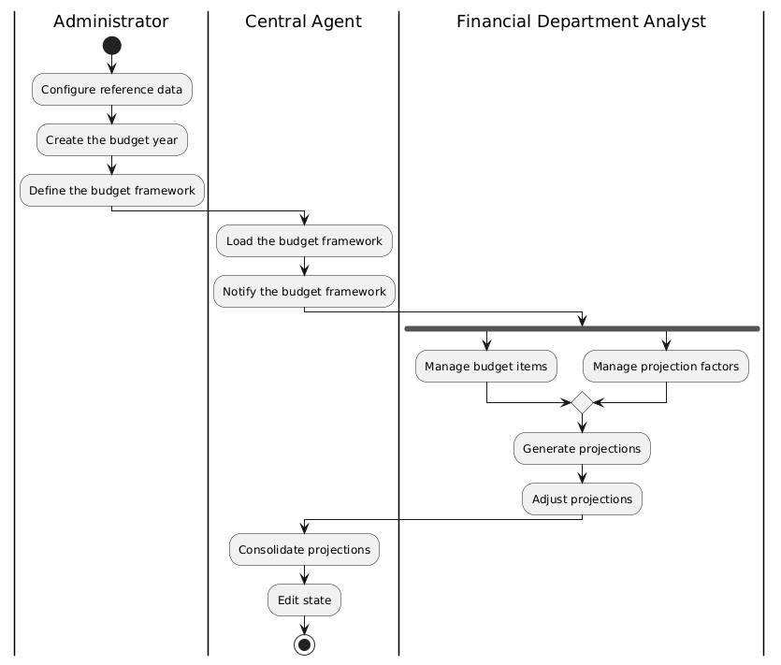
The activity diagram represents the flow of business processes within the system. It describes the sequence of actions, conditions, choices, and parallel flows involved in the execution of a scenario. It allows for the analysis of the system's dynamic behavior and clarifies the processing logic.

II-3 Sequence diagram
The sequence diagram illustrates the chronological sequence of interactions between the various actors and the system during the budgeting and forecasting process.
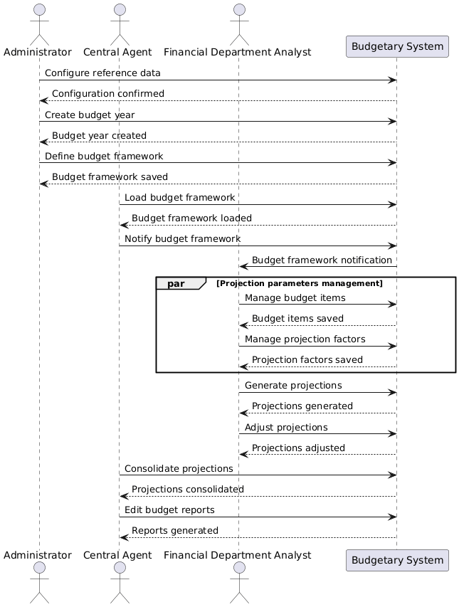
It highlights the order of exchanges, the responsibilities of the actors, and the processing performed by the system.

PART III :
REALIZATION

